**Injecting Hope**

25 January – 27 April 2025

**Visual Guide**

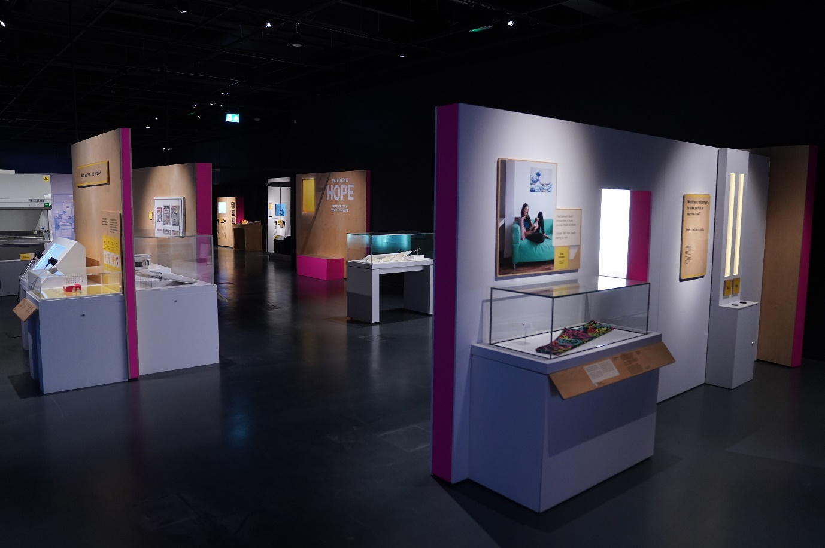

National Museum of Scotland

Chambers Street

Edinburgh

EH1 1JF

This visual guide is designed to support a visit to the exhibition *Injecting Hope* at the National Museum of Scotland.

Visiting the National Museum of Scotland 2

Visiting the exhibition 4

General information 5

Notes on the exhibition 5

Relaxed Viewings of Injecting Hope 5

Getting to the exhibition 5

Toilets 6

Exhibition Sensory Map 7

A visual walk through the exhibition 7

Exhibition exit and shop 16

# Visiting the National Museum of Scotland

There are two entrances to the National Museum of Scotland.

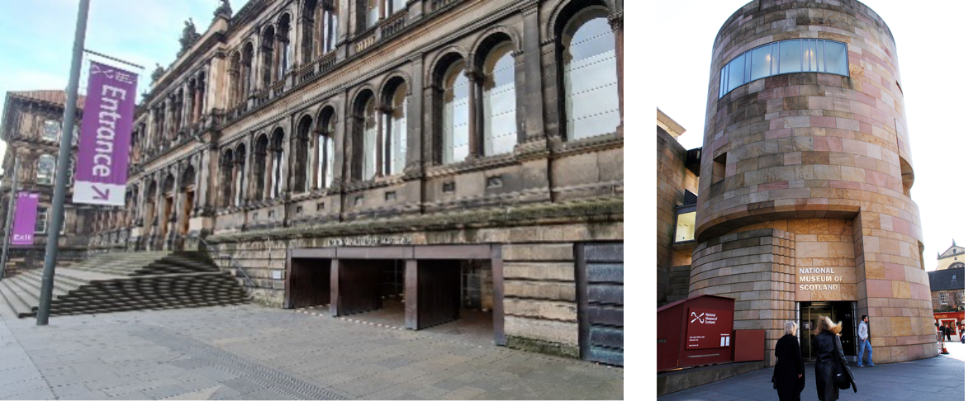

The Main Entrance The Tower Entrance

The Tower Entrance is usually quieter and offers step-free access to the museum.

Please visit our ‘Plan Your Visit’ webpage: <https://www.nms.ac.uk/national-museum-of-scotland/plan-your-visit/> for more information about getting to the museum, facilities, and accessible parking. You can also download a [map of the museum](https://www.nms.ac.uk/media/1166814/scotlandmapstage8_download.pdf).

Guide dogs and assistance animals are welcome in all areas of the museum.

General visual stories are available to support your visit:

[Main entrance visual story](https://www.nms.ac.uk/media/1166566/visual-story-main-entrance-updated-26-july-2022.pdf)

[Tower Entrance visual story](https://www.nms.ac.uk/media/1166565/visual-story-tower-entrance-updated-26-july-2022.pdf)

To find out more about accessibility at the museum please visit: <https://www.nms.ac.uk/national-museum-of-scotland/plan-your-visit/accessibility/>

When you arrive at the museum, there are information desks at both entrances. If you would like to pick up a map or if you have any questions, our Visitor Experience staff can help you.

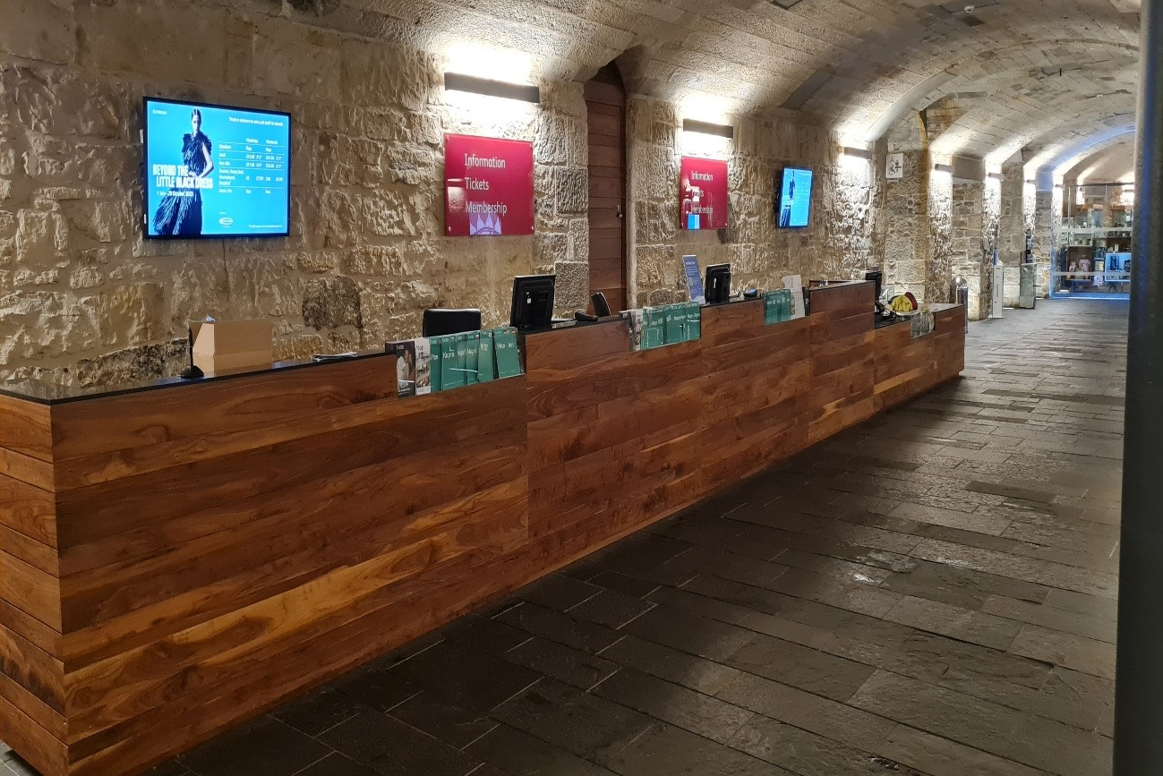

Our visitor experience staff wear purple shirts and lanyards and are available throughout the museum.

Two people wearing the purple and navy uniforms of Visitor Experience staff.



**A limited number of sensory maps of the museum and sensory backpacks are available to borrow for free from the information desks.**

# Visiting the exhibition

## General information

This exhibition details the rapid research, development and delivery of the vaccine.

The exhibition brings together more than 80 objects that were acquired in real time during the peak of the pandemic by curators across the UK.

Injecting Hope will also share uniquely Scottish experiences of the global pandemic.

## Notes on the exhibition

* Personal photography is encouraged but flash is not allowed. Filming is permitted for personal, not-commercial use, on a personal device.
* No eating or drinking in the exhibition.
* There are wooden benches available in the exhibition. Portable foldable stools are also available at the exhibition entrance.
* Large print guides are available in a holder through the entrance door to the left as you go in.
* To ensure a positive experience for all visitors, the maximum time allowance within the exhibition space is two hours.
* Light levels are low in the exhibition.
* Child/adult ear defenders are available to borrow from the Exhibition Desk.
* There are stations with wipes in the exhibition should you wish to use them.
* There are many screens at different heights but the average mid-point is 145cm from the floor.
* For more information about the accessibility of the exhibition please visit the exhibition website: <https://www.nms.ac.uk/exhibitions/injecting-hope>

## Relaxed Viewings of Injecting Hope

Relaxed viewings of *Injecting Hope* will be held at the following dates/times:

**Morning sessions: Sunday 2nd February, 2nd March, 6th April, 10:00 – 12:00**

**Evening session: Thursday 6th March, 5:30 – 7:30**

During Relaxed Viewings, visitor numbers will be reduced and the volume of some of the visual displays.

## Getting to the exhibition

***Injecting Hope*** is in Special Exhibition Gallery 1 on Level 3 of the museum.   
Level 3 is accessible via a lift, an escalator, or stairs.

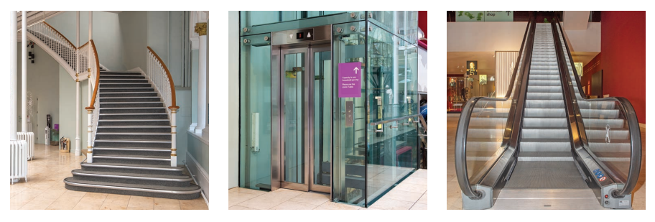

The entrance to the exhibition is on **Level 3**. Here you will be greeted by museum staff. 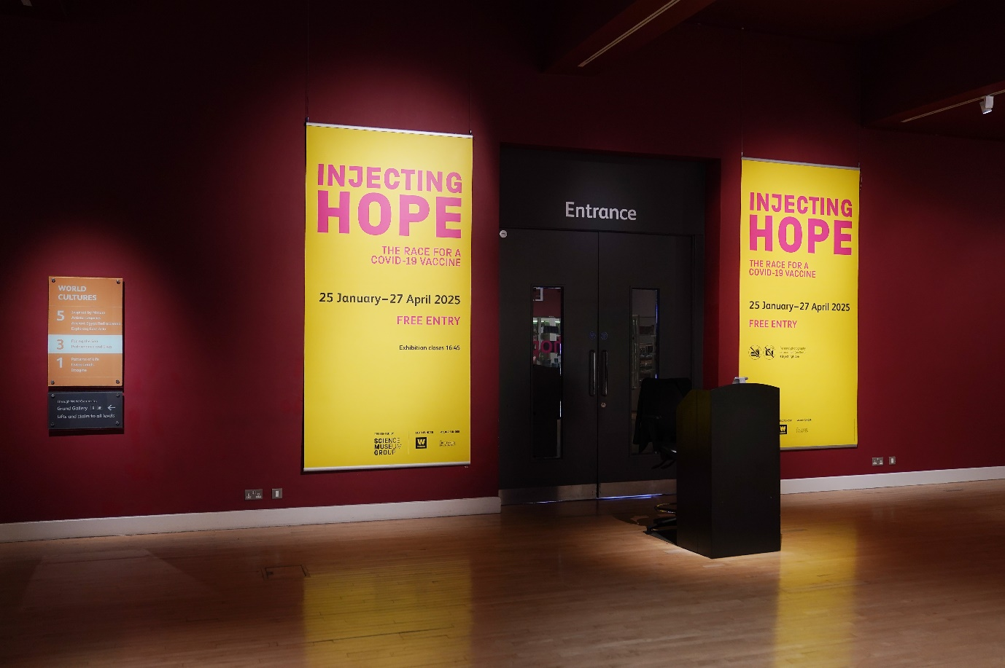

## Toilets

The nearest toilets (including an accessible toilet) to the exhibition are on **Level 3** through the *Making and Creating* gallery. There is a Changing Places (U) toilet available in the Level 0 Entrance Hall. It is opened with a RADAR key. One is available at the information desk next to the toilet entrance if you do not have your own. Toilets and accessible toilets are available on every level of the museum.

## Exhibition Sensory Map

Printed copies of the Sensory Map are available to borrow from the Exhibition Information Desk on Level 3.

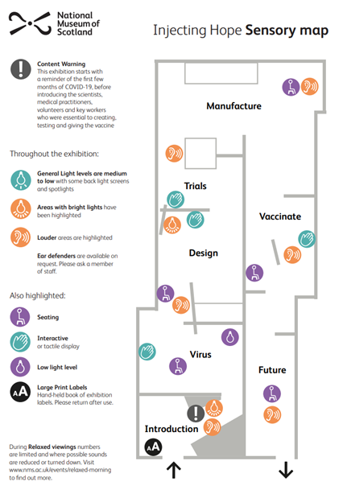

# A visual walk through the exhibition

**Introduction**

In the beginning you will see large a board of information discussing the emergence of Covid-19, the pandemic and the rapid scientific response through creating a vaccine.

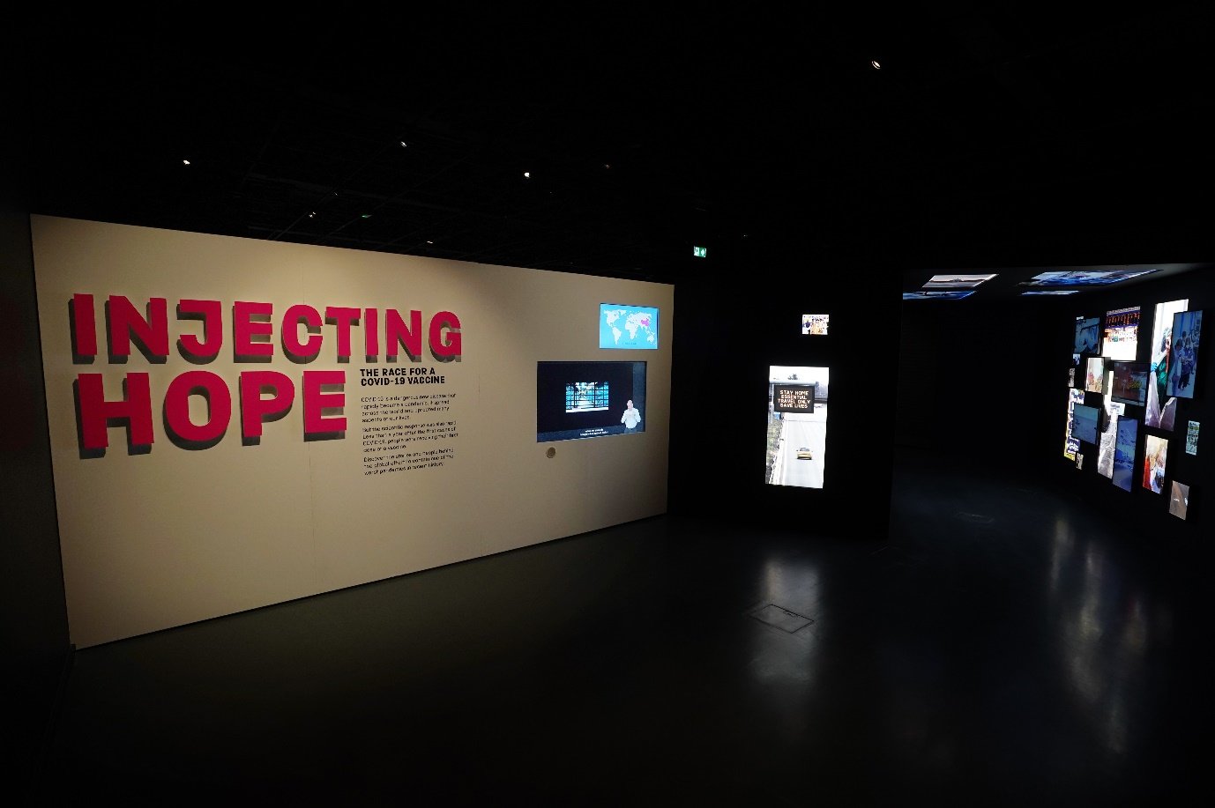Text Box

Large print labels and copies of the exhibition text are available to borrow from stands on the left hand side of the entrance as you go in. Please return them to the stands by the exit when you have finished your visit.

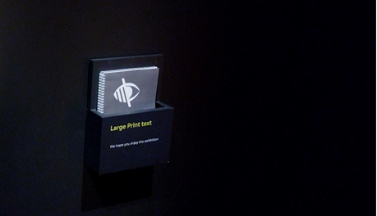

When entering the exhibit, there is a tunnel featuring images and sounds relating to the lockdown in response to the Covid-19 pandemic.

This area has bright lights and sounds that are louder than normal.

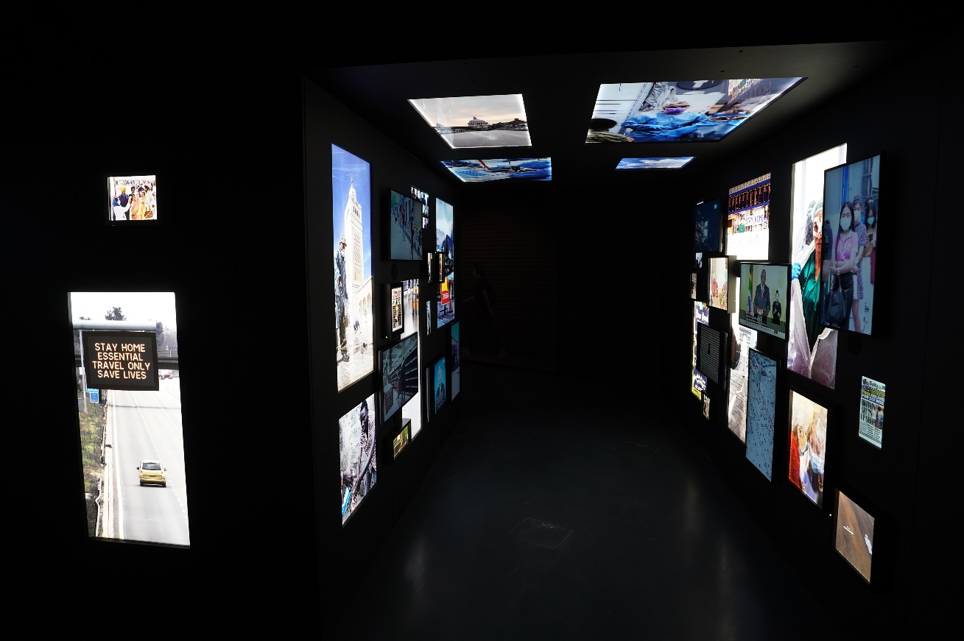

**Virus**

This area discusses the coronavirus, how it emerged and spread. This section has low level light and an interactive display.

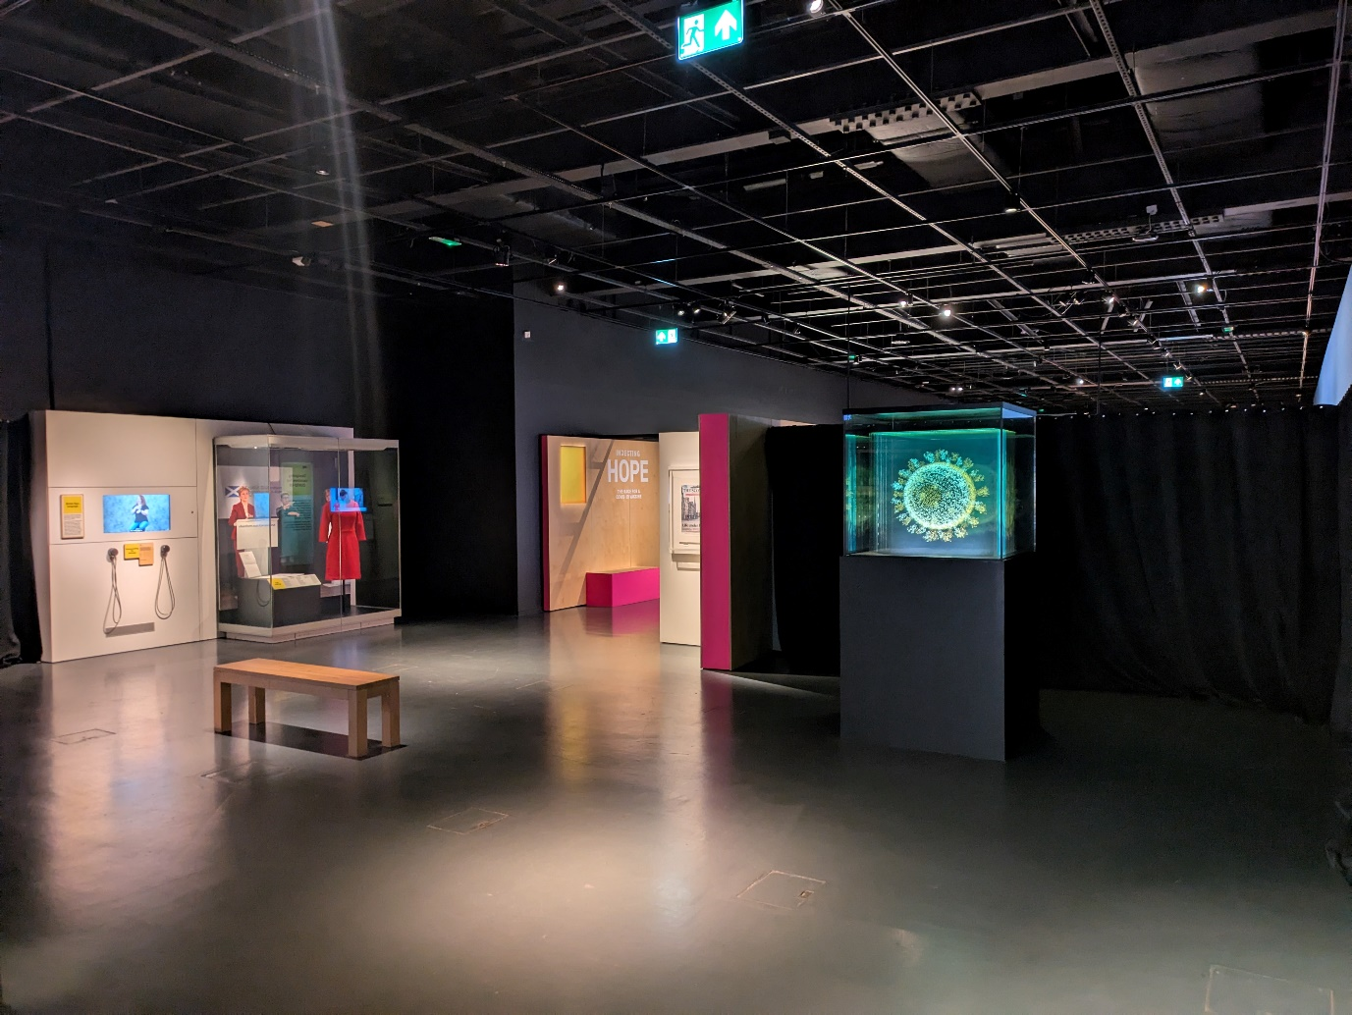

**Design**

Before entering the Design section there is a video discussing the medical response to the Covid-19 pandemic. This section begins in a low light and a video display may be louder than usual. There is a bright light next to the ‘Origin of the Vaccine’ display.

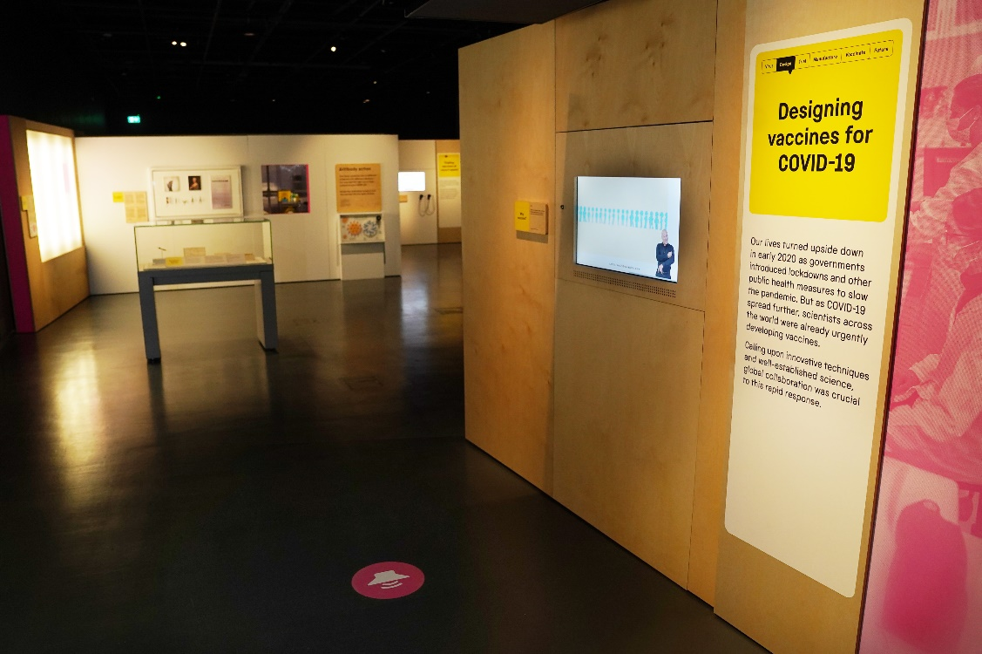

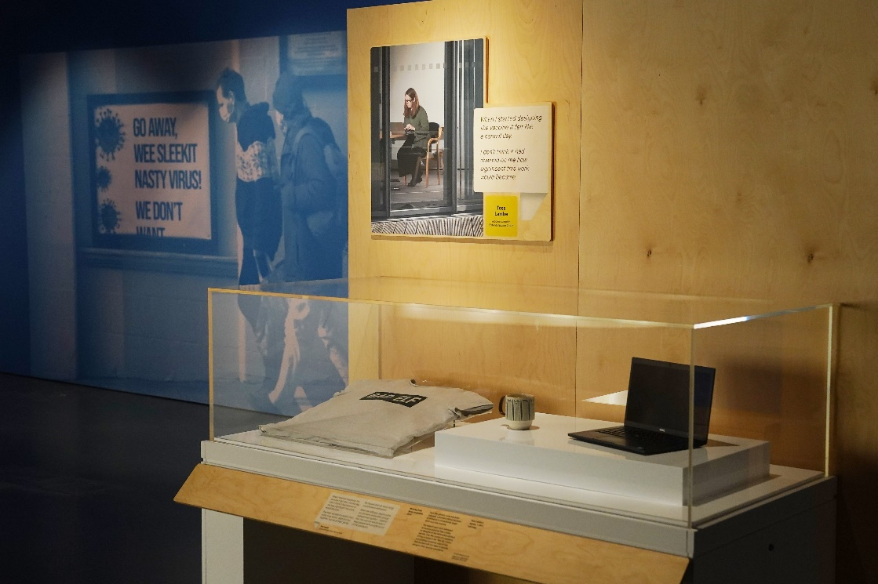

**Trials**

This section will be discussing the trials of the vaccines that were conducted. This includes a video that may be louder than usual.

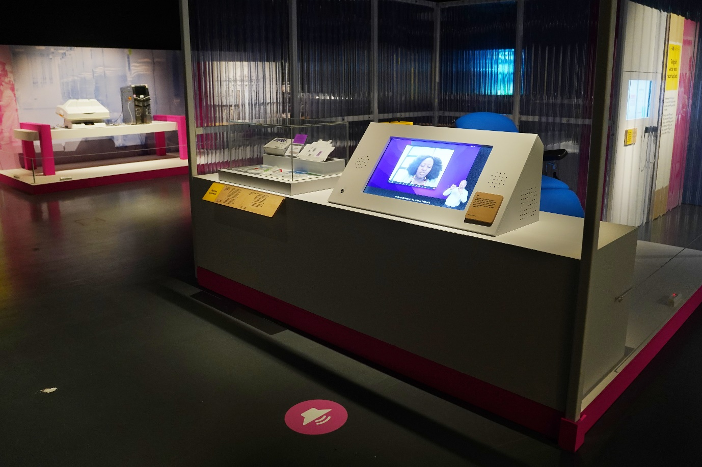

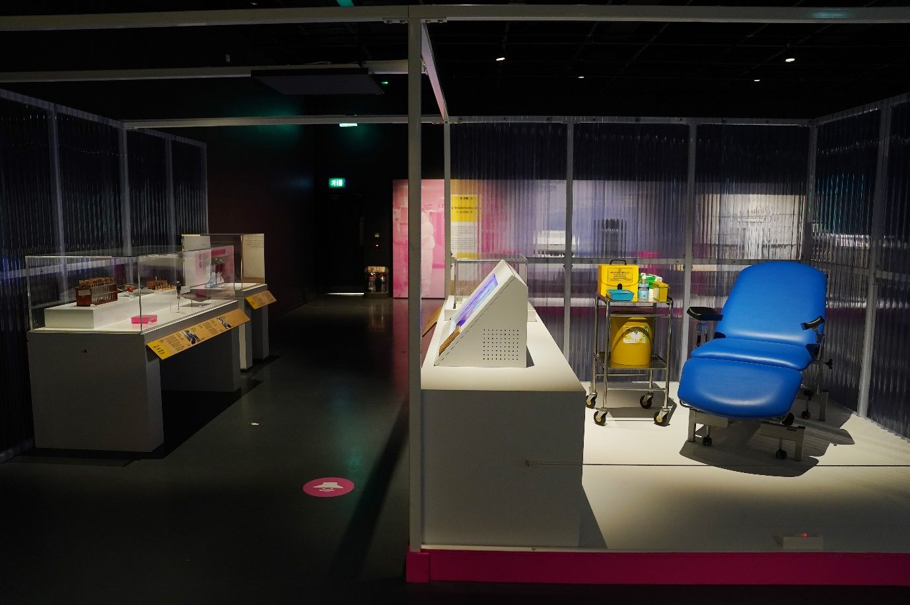

**Manufacturing**

**Manufacturing**

This section features information and machinery used to manufacture and produce the Covid-19 vaccine at a large scale. This also features a loud video depicting the manufacturing of the vaccine.

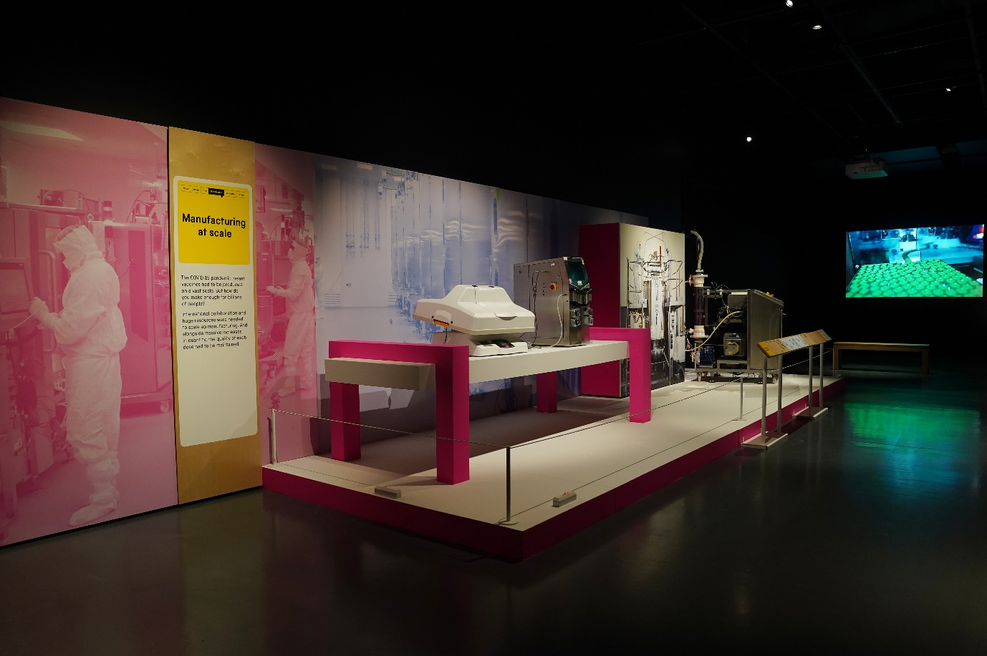

**Vaccinate**

This area discusses the vaccine itself as well as items such as pamphlets and letters about the vaccine and getting vaccinated. There is a visual and interactive display in this section.

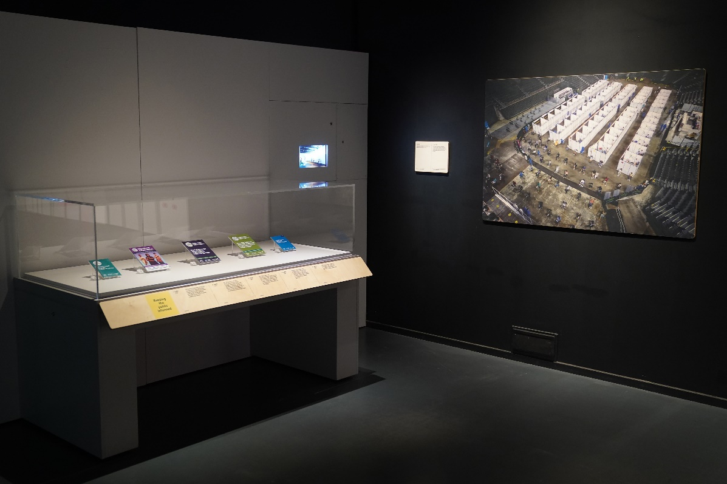

**Future**

This is the final section of the exhibit and has a seating area as well as a voice speaking overhead as an auditory display.

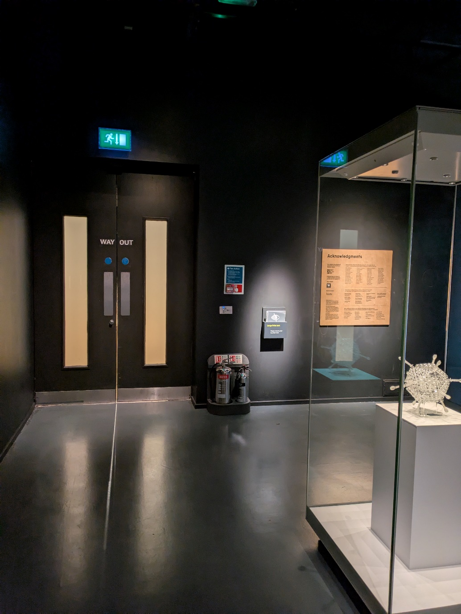

## Exhibition exit and shop

You will exit the exhibition through this door.

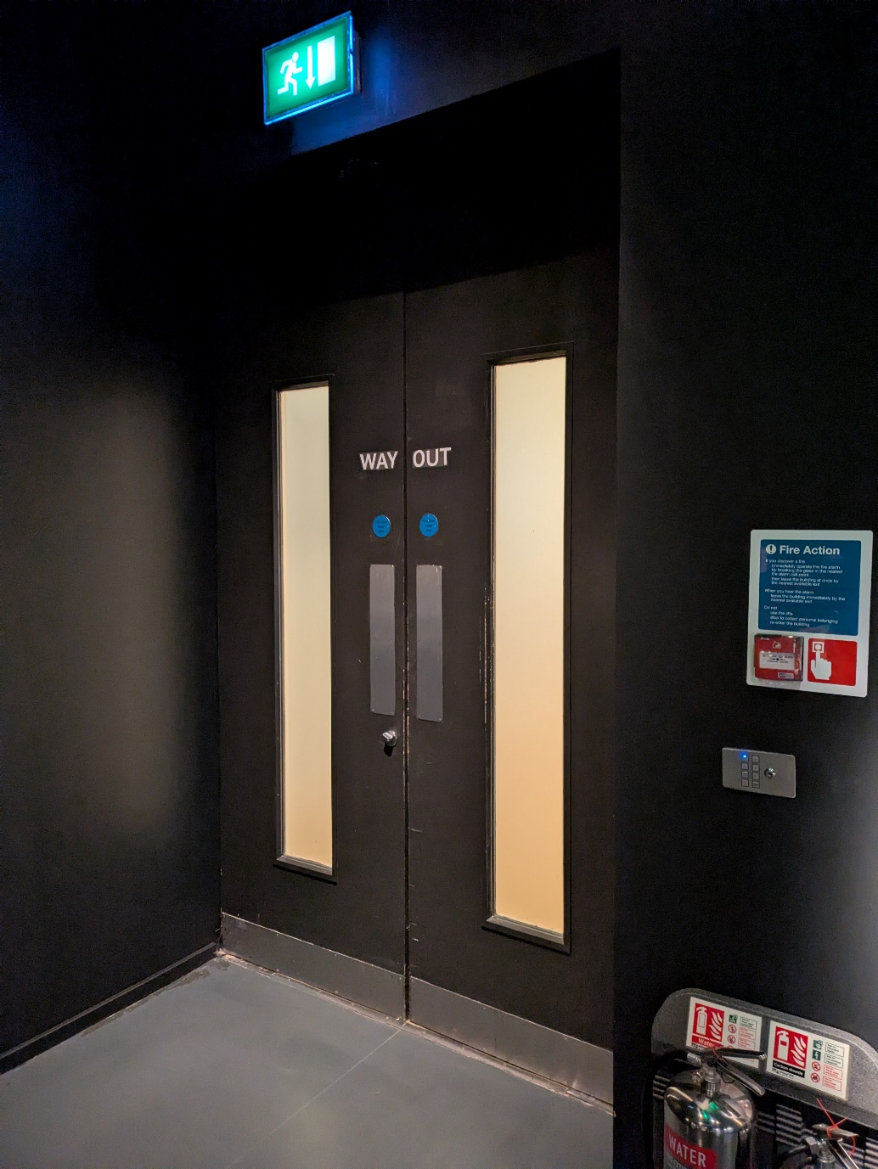

The Exhibition Shop is opposite the exit.

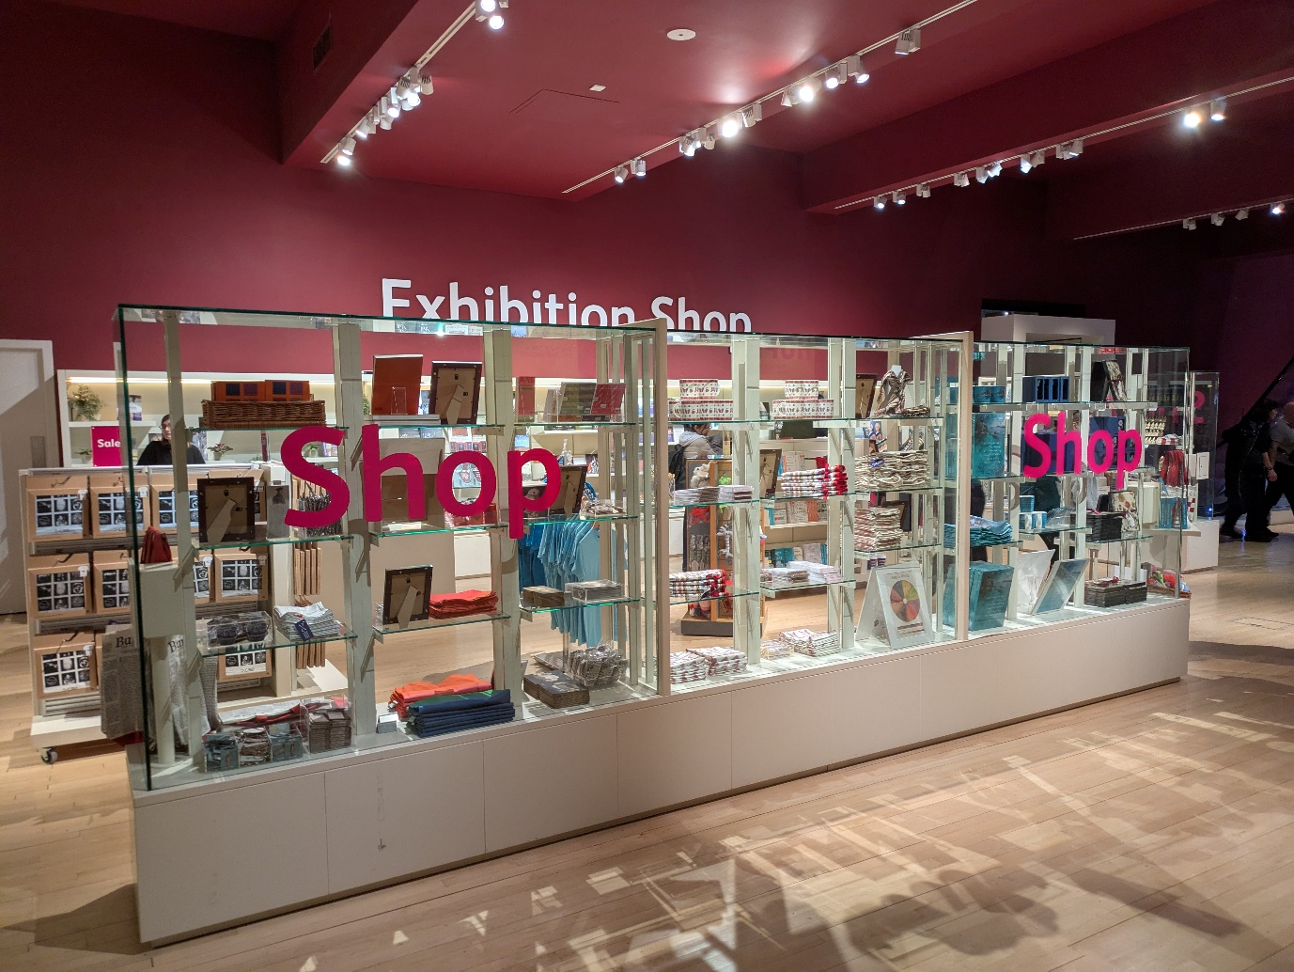

**We hope you enjoy your visit.**

Contact us

If you require any further information about the museum or the exhibition please use the following contact details:

Email: [communities@nms.ac.uk](mailto:communities@nms.ac.uk)

Call: 0300 123 6789 (Monday-Friday, 10:00–17:00)

Or visit our website [www.nms.ac.uk](http://www.nms.ac.uk/)