**Game On**

29 June – 3 November 2024

**Visual Guide**

National Museum of Scotland

Chambers Street

Edinburgh

EH1 1JF

This visual guide is designed to support a visit to the exhibition *Game On* at the National Museum of Scotland.

Contents

Visiting the National Museum of Scotland 3

Tickets 3

Visiting the exhibition 5

General information 5

Notes on the exhibition 5

Relaxed Viewings of Game On 5

Getting to the exhibition 6

Toilets 6

Exhibition Sensory Map 7

A visual walk through the exhibition 8

Exhibition exit and shop 13

Contact us 14

# Visiting the National Museum of Scotland

There are two entrances to the National Museum of Scotland.

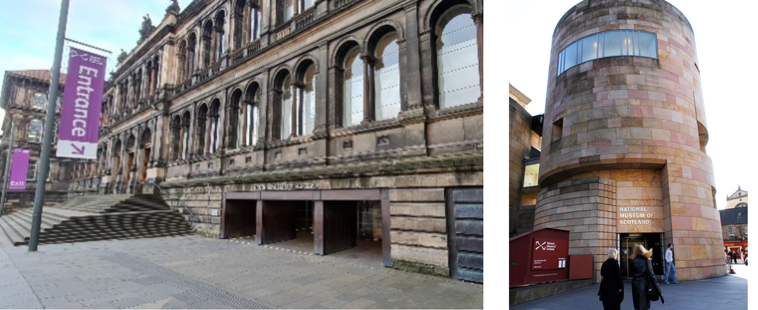

The Main Entrance The Tower Entrance

The Tower Entrance is usually quieter and offers step-free access to the museum.

Please visit our ‘Plan Your Visit’ webpage: <https://www.nms.ac.uk/national-museum-of-scotland/plan-your-visit/> for more information about getting to the museum, facilities, and accessible parking. You can also download a [map of the museum](https://www.nms.ac.uk/media/1166814/scotlandmapstage8_download.pdf).

Guide dogs and assistance animals are welcome in all areas of the museum.

General visual stories are available to support your visit:

[Main entrance visual story](https://www.nms.ac.uk/media/1166566/visual-story-main-entrance-updated-26-july-2022.pdf)

[Tower Entrance visual story](https://www.nms.ac.uk/media/1166565/visual-story-tower-entrance-updated-26-july-2022.pdf)

To find out more about accessibility at the museum please visit: <https://www.nms.ac.uk/national-museum-of-scotland/plan-your-visit/accessibility/>

# Tickets

A general visit to the museum is free and no booking is required. However, to visit the ***Game On* exhibition you will have to buy a ticket.** Tickets can be purchased online ([click to visit the booking page](https://my.nms.ac.uk/events/13096?view=calendar&startDate=2024-06-28)) or purchased at either the Main Entrance Information Desk on level 0 or outside the exhibition on Level 3 subject to availability. Tickets are cheaper when purchased in advance of your visit (up to 24 hours before visiting). **We recommend booking in advance to avoid disappointment.**

If you need any help with booking tickets, please call 0300 123 6789 (10:00-17:00).

To find out about ticket pricing please visit our website: <https://www.nms.ac.uk/exhibitions-events/exhibitions/national-museum-of-scotland/game-on/>

When you arrive at the museum, there are information desks at both entrances. If you would like to pick up a map or if you have any questions, our Visitor Experience staff can help you.

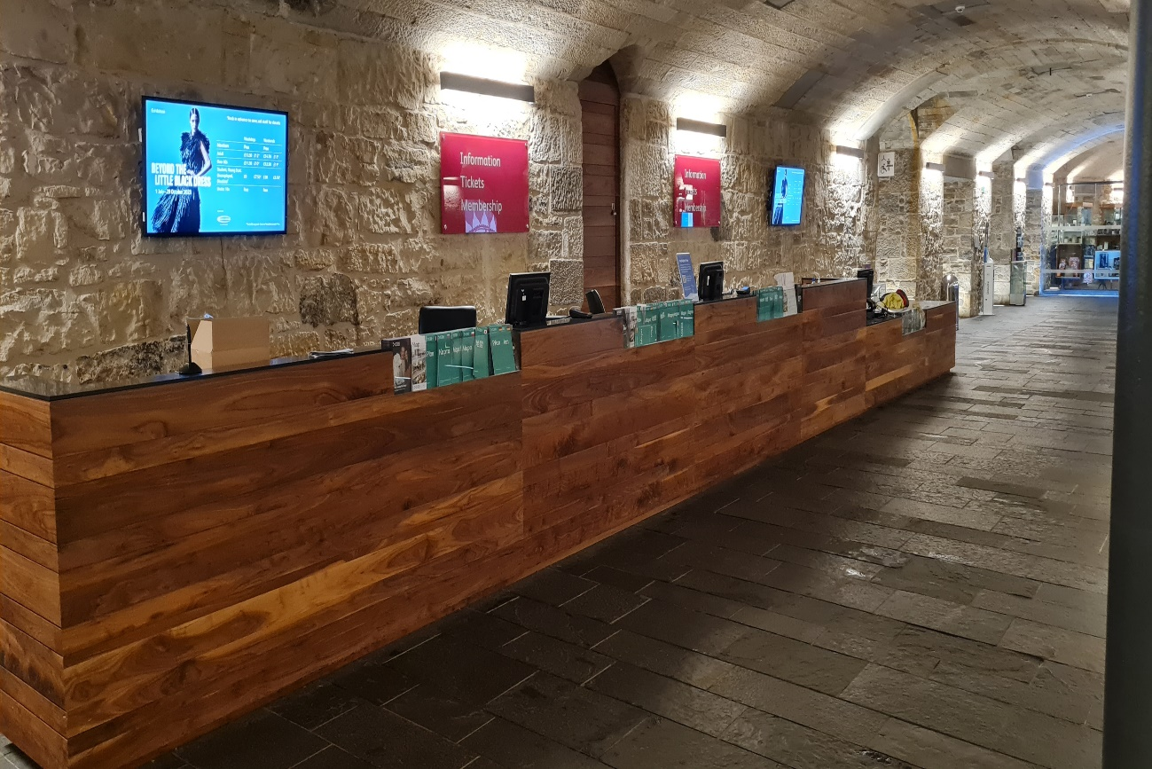

Our visitor experience staff wear purple shirts and lanyards and are available throughout the museum.

Two people wearing the purple and navy uniforms of Visitor Experience staff.



**A limited number of sensory maps of the museum and sensory backpacks are available to borrow for free from the information desks.**

# Visiting the exhibition

## General information

Game On is the largest interactive exhibition of the history and the culture of video games.

Conceived and curated by Barbican Immersive, Game On explores the creative and technological advances within the gaming industry. ​

From Sonic the Hedgehog to Mario, explore gaming's rich history by playing many of the key games produced over the last 50 years.

**Please note: this exhibition contains some games that have an age restriction.** Please contact [info@nms.ac.uk](mailto:info@nms.ac.uk) for more information.

## Notes on the exhibition

* Personal photography is encouraged but flash is not allowed. Filming is permitted for personal, not-commercial use, on a personal device.
* No eating or drinking in the exhibition.
* There are wooden benches available in the exhibition. Portable foldable stools are also available at the exhibition entrance.
* Large print guides are available in a holder through the entrance door to the left as you go in.
* To ensure a positive experience for all visitors, the maximum time allowance within the exhibition space is two hours.
* Game On is a very interactive and sensory exhibition with games including lights, colour changes and sounds.
* Light levels are low in the exhibition.
* Child/adult ear defenders are available to borrow from the Exhibition Desk.
* There are stations with wipes in the exhibition should you wish to use them.
* There are many screens at different heights but the average mid-point is 145cm from the floor.
* For more information about the accessibility of the exhibition please visit the exhibition website: <https://www.nms.ac.uk/exhibitions-events/exhibitions/national-museum-of-scotland/game-on/>

## Relaxed Viewings of Game On

Relaxed viewings of *Game On* will be held at the following dates/times:

**Sunday 7 July 2024, 10:00–12:00**

**Sunday 4 August 2024, 10:00–12:00**

**Sunday 1 September 2024, 10:00–12:00**

**Tuesday 10 September 2024, 17:30–19:30** (please note this is an after-hours viewing)

**Sunday 6 Oct April 2024, 10:00–12:00**

During Relaxed Viewings, visitor numbers will be reduced and the volume of some of the noisiest games turned down. Standard exhibition entry costs apply.

## Getting to the exhibition

***Game On*** is in Special Exhibition Gallery 1 on Level 3 of the museum.   
Level 3 is accessible via a lift, an escalator, or stairs.

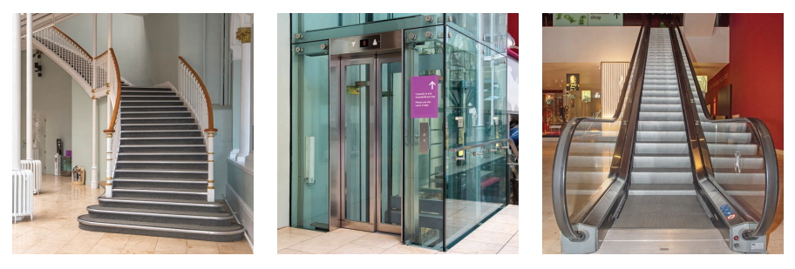

The entrance to the exhibition is on **Level 3**. Here you will be greeted by museum staff who will scan your ticket.

If you do not have a ticket, you can buy one at the exhibition ticket desk if available.

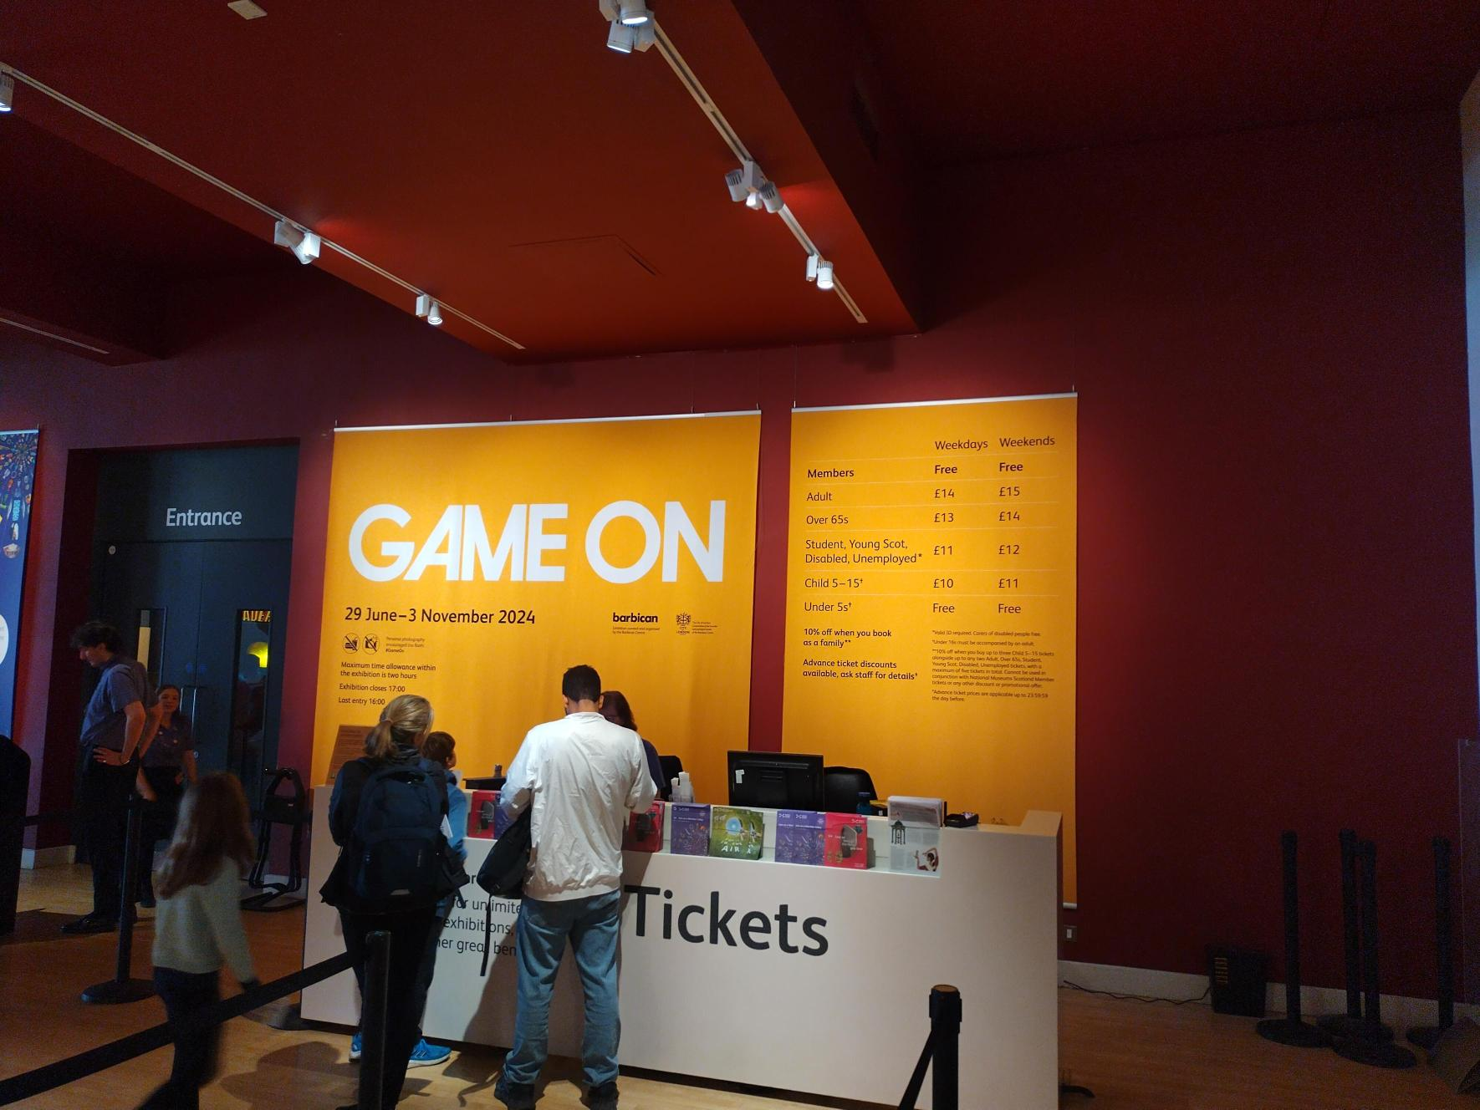

## Toilets

The nearest toilets (including an accessible toilet) to the exhibition are on **Level 3** through the *Making and Creating* gallery. There is a Changing Places (U) toilet available in the Level 0 Entrance Hall. It is opened with a RADAR key. One is available at the information desk next to the toilet entrance if you do not have your own. Toilets and accessible toilets are available on every level of the museum.

## Exhibition Sensory Map

Printed copies of the Sensory Map are available to borrow from the Exhibition Information Desk on Level 3.

# A visual walk through the exhibition

**Early games**

Early games introduces early arcade and other games from the 1970s onwards. This area is quieter, although the *Space Invaders* game does make a loud noise when being played.

Large print labels and copies of the exhibition text are available to borrow from stands on the left hand side of the entrance as you go in. Please return them to the stands by the exit when you have finished your visit.

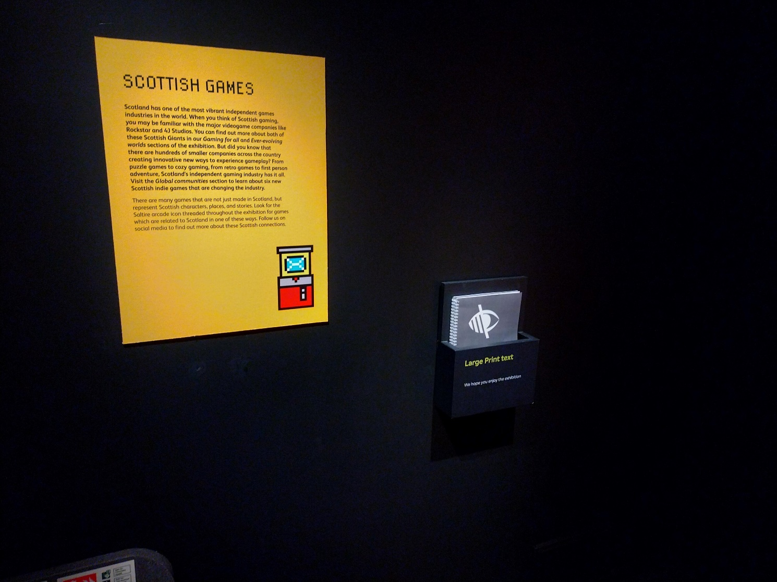

**Top Ten**

In this area, some of the games can be noisy.

**Arcades**

This area has a number of arcade games which are loud and have flashing lights, particularly the *Daytona USA2* game shown below.

**Characters/Global community/Playing together/Genres**

These sections are a bit quieter and calmer. In this section there is a game with an adaptive controller called *Pine Hearts*. The controllers allow a wider range of users with motor disabilities to play it.

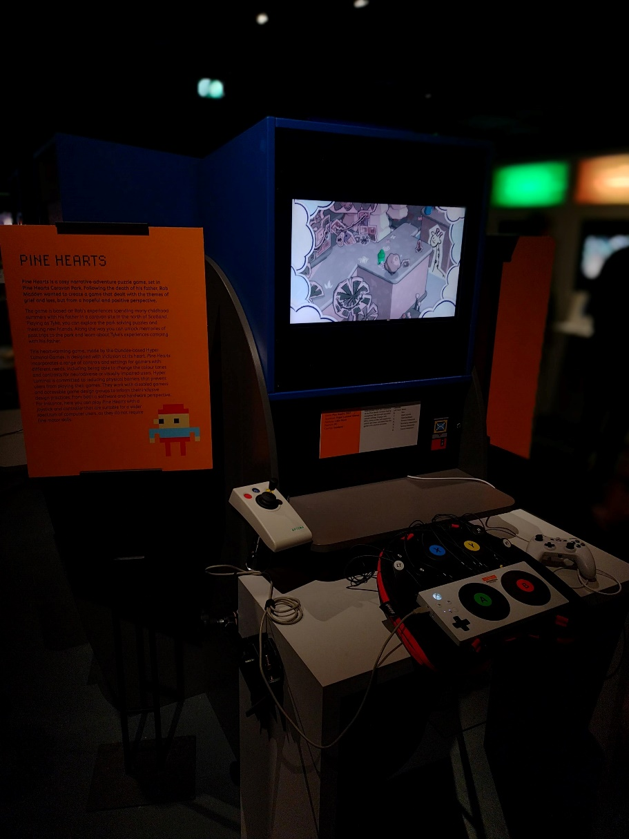

**Beyond pixels and play**

This area is the loudest area as it has music based games including *Just Dance* and *Beatles Rock Band*. We will turn down the volume of these during our Relaxed Viewings. Three of the games – *Rez*, *Guitar Hero*, *Parappa the Rapper* have headphones.

This area also includes one 18+ game, *Blade Runner,* which contains an age warning.

**Gaming for all/Handheld games**

This area is a quieter, family friendly area with low seating and less noisy games. In this section, *Minecraft* has an adaptive controller to allow a wider range of users with motor disabilities to play.

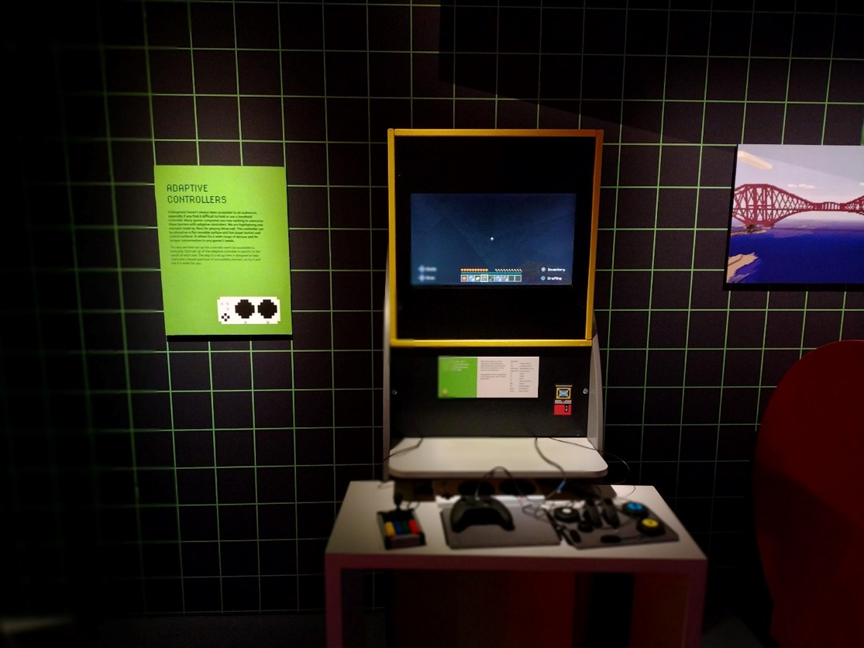

**Ever-evolving worlds**

This area has three games with age and content trigger warnings as they contain over 18+ only imagery or subject matter which some people may find upsetting. It also has a large screen for a VR game which has louder noises and moving images.

## Exhibition exit and shop

You will exit the exhibition through this door.

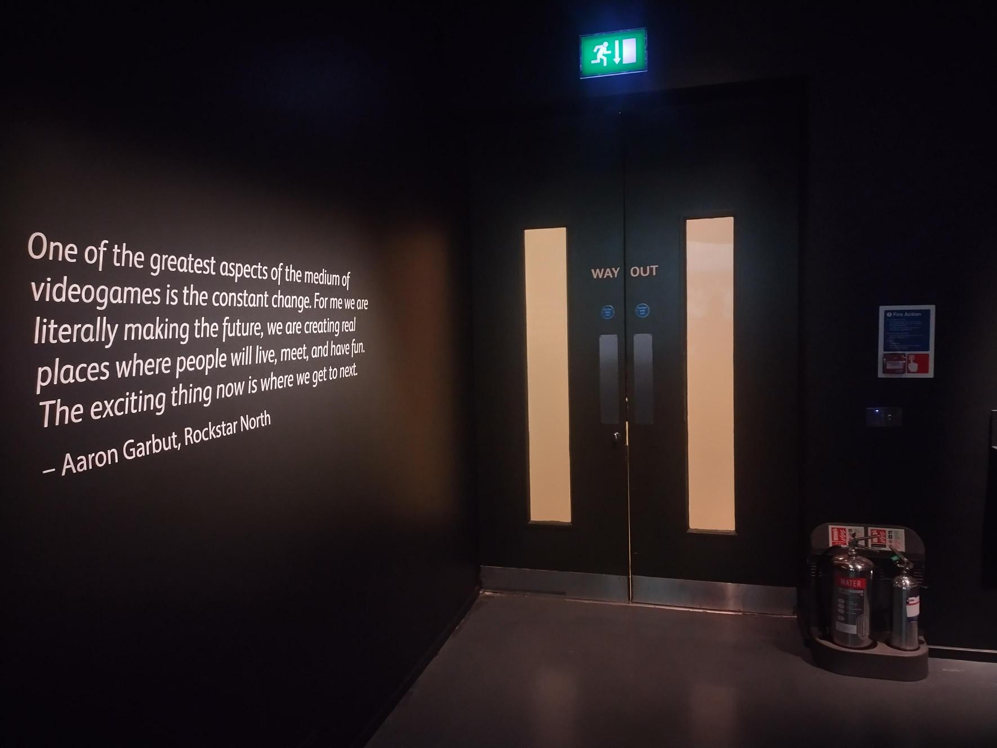

The Exhibition Shop is opposite the exit.

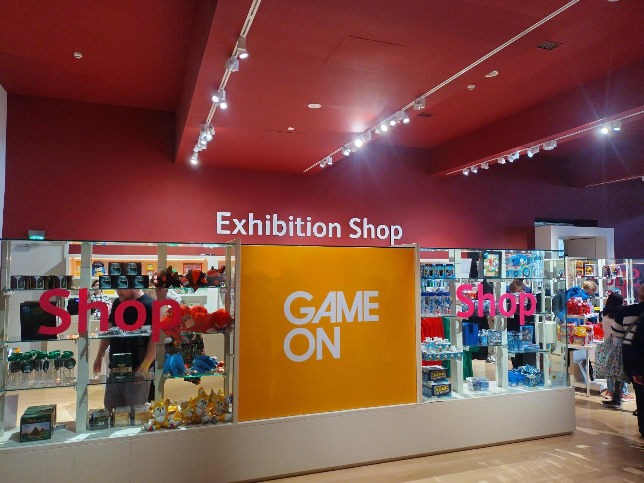

**We hope you enjoy your visit.**

# Contact us

If you require any further information about the museum or the exhibition please use the following contact details:

Email: [communities@nms.ac.uk](mailto:communities@nms.ac.uk)

Call: 0300 123 6789 (Monday-Friday, 10:00–17:00)

Or visit our website [www.nms.ac.uk](http://www.nms.ac.uk)